Greetings from Special Olympics Bharat
A National Camp brings the Snow Sporters together just before the winter bids farewell
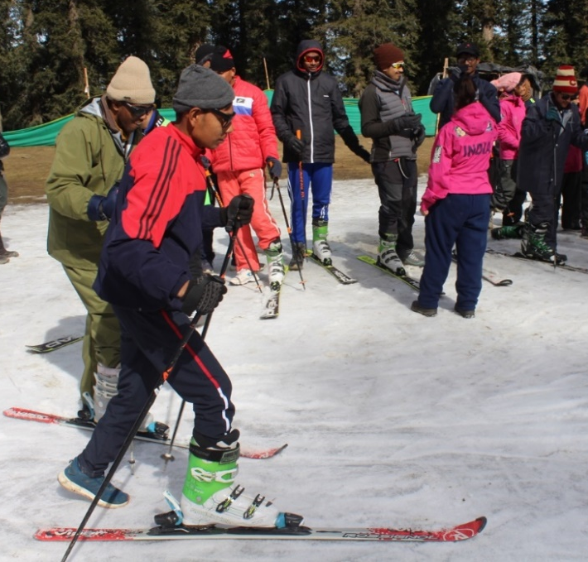
It was in 1993 that India participated at the World Winter Games for the first time. 18 delegates represented India at the event held in Schladming, Austria with and returned with a Gold Medal. Since then, India has come a long way having participated in five more World Winter Games. For the first time ever, snow sports were introduced to the SO Bharat Athletes in 2007 against the breath-taking backdrop of Narkanda, Himachal Pradesh. The first ever National games in winter sports was held in this very state in 2008. SO Bharat opened a new chapter in its journey, introducing the Athletes and Coaches to the world of snow, no matter which part of the country they belonged to. Between 1993 and 2017 approx. 240 special athletes have participated at the Special Olympics World Winter Games winning 167 medals in all.
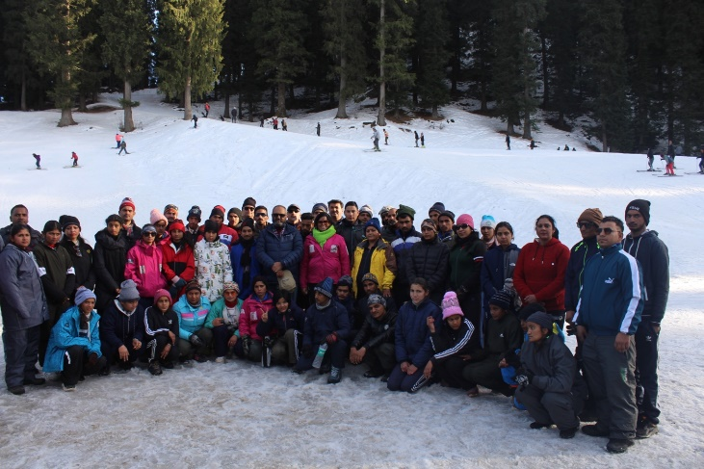
Bringing back the memories of development and progress, a National Coaching Camp was held in February 2023 at the same location that saw its genesis, bringing together over 180 Athletes, Coaches & Resource Persons from 12 States of India. Under the guidance and supervision of a resource team from The High-Altitude Trekking & Skiing Centre, Narkanda. The Camp, once again, as in all snow sport camps, rolled out the meticulous process of issuing sport equipment. The process calls for a briefing by itself, apart from focussing on skill development. The ability of the Athlete to carry the equipment with himself/herself is considered an important criterion. Snow boards, Snow shoes as well as Alpine skis weigh around 5 to 7 kgs or more. While the correct size impacts performance, having being able to carry the equipment ensures safety of the participant in a situation of a fall or any such accident. Acclimatizing to the cold, too, is a factor to be considered equally for both, the Athlete and the Coach. Leading the Camp in Himachal Pradesh, Mr Harpreet Singh, Jt National Director- Sports said, “Our constant endeavor is to extend the opportunity of snow sports to more states in India, despite contradictory weather conditions. It has been observed through past experiences, that the Athletes can flex into sports that may not be popular in their local surroundings, so why not keep multiplying opportunities for them to play”
Kolkata speaks Inclusion on World Theatre Day 2023
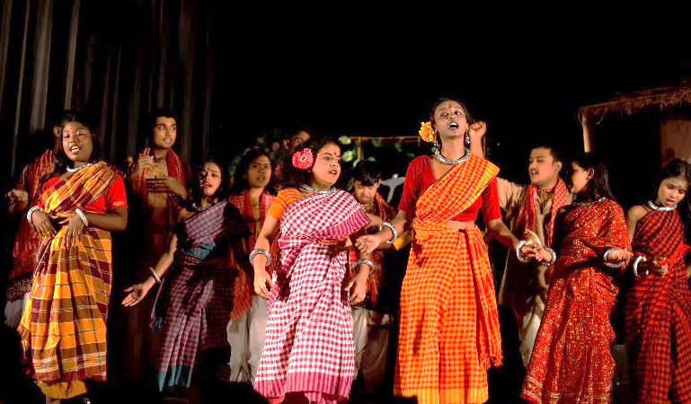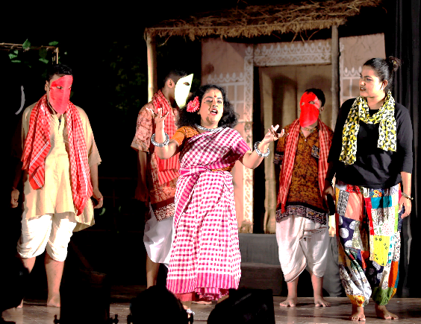
Debangana Dasgupta, Youth with ID and Renaissan Dutta, Youth without ID met each other through theatre that formed an integral part of the Innovation Grant project led by them in the state of West Bengal. Their project brought them together in 2021, as it brought over 15 special athletes, many like Debangana demonstrating their talent outside the sports field. While Debangana started to overcome restlessness and developed into an uninhibited speaker, Rennaisan overcame her performance anxiety. Commenting on their developing friendship, Ms Nupur, their adult mentor commented, “They slowly started leading the activity, then the script, then the whole drama. As the project progressed, their friendship grew deeper. Moreover, they both created a friendly environment for others as well. Unified theatre is not just about putting on a show, it is about creating inclusion in the community where everyone’s voice is heard, valued, and celebrated”. The success of theatre had the pair reach out to many government schools in the city, where already ten of them are replicating the model.
To honour and celebrate the beauty and hard work of the overall theatrical production, International Theatre Institute (ITI) created World Theatre Day in 1962. Theatre began as a private entertainment in Kolkata in the early 19th century. Bengali theatres have played a pivotal role in manifesting popular emotions, opinions, and messages. Kolkata even now, leverages the platform for the purpose, and the Special Olympics youth spread the message to ‘Accept and Include’ View Post
Partnering to make Health care inclusive and accessible
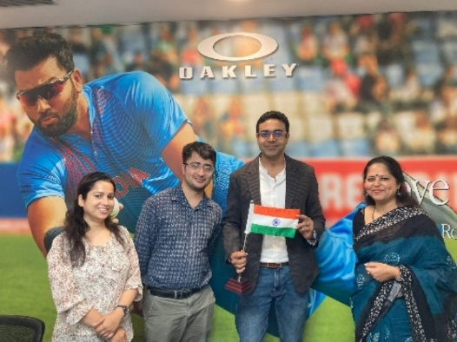
On the path of making health care inclusive and accessible, SO Bharat is continuously forging new partnerships as well as strengthening the existing ones. Very recently a team from the National office visited the office of ‘Onesight’, which is a registered charitable organization, reflecting the commitment and values of Essilor Luxottica Foundation. Their mission to eliminate uncorrected poor vision, aims to leave no one behind. 23.1 Persons with Intellectual Disability, world over, have never had an eye examination, and SO Bharat with philanthropists and passionate partners, endeavours to overcome the challenge. One Sight Essilor Luxottica Foundation has volunteered to provide lenses to the Athletes who participate in an upcoming Berlin games preparatory camp to be held in the Delhi NCR. Following the Games, a sustainable plan would be designed wherein the organisation will also support SO Bharat with identifying children with IDD through their community programs.

Equal standing finally for the Special Athletes by the Bihar Government
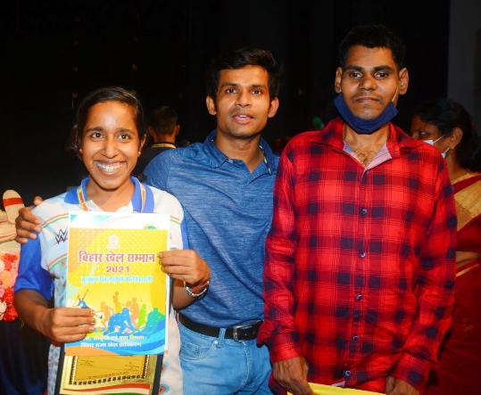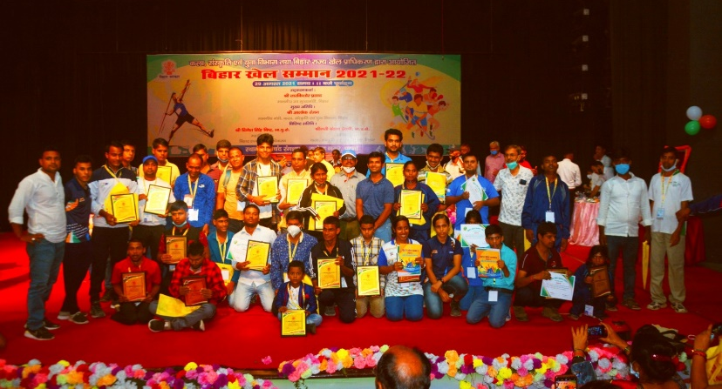
The fight for equal status for the Athletes of Special Olympics in the state dates to 2000 when Khel Samman was commenced. Babur, the first ever athlete from Bihar at the World Winter Games held in Ireland in 2003, witnessed it all. Although the state felicitated the medallists, the difference in the prize money awarded to the athletes with and without Intellectual Disabilities was significant. Mr Sandeep Kumar, the now, Area Director of Bihar with the support of Dr Shivaji Kumar, the President of the state kept the flame of hope burning. They did not leave any stone unturned, finally resorting to Clause 3 of the RPWD (Rights of Persons with Disabilities) Act 2016 that explicitly denounces any person to be discriminated on the ground of disability. State Government Notification
Recently, the Govt of Bihar announced that on the National Sports day, observed later this year, the SO Bharat athletes will be felicitated with an equal amount to the players without ID. The athletes from the Special Olympics National Games and championship will be given Rs.2 lakh for Gold Rs.1.5 lakh for Silver and Rs.1 lakh for a Bronze Medal. Additionally, the state chapter will support the State Govt in selecting the Athletes for getting jobs according to their abilities. Ecstatic about this landmark achievement, Mr Sandeep says that this is a giant step towards mainstreaming the Athletes.

An invitation to the Youth of SO Bharat by UNICEF YuWaah
A group of youth leaders with and without Intellectual Disabilities were invited by the UNICEF-Yuwaah team for the first ever User Acceptance Testing of the YuWaah Aggregator Platform. Inputs were requested from a diverse but small group of people including youth at Special Olympics Bharat, Afghanistan refugees and gender equality advocates from Her Haq. The Youth Leaders and Athletes from SOB downloaded the 0.5 version of the application to test it for bugs, accessibility for people with intellectual disabilities and features and thereafter filled the test cases and feedback form.

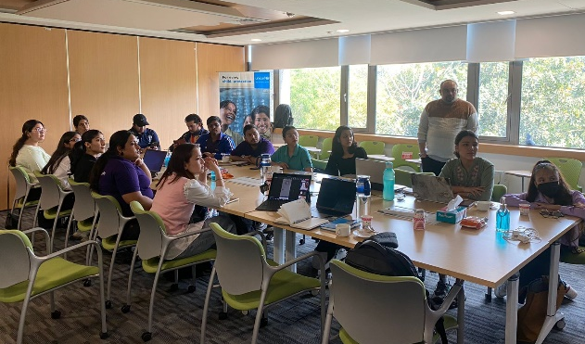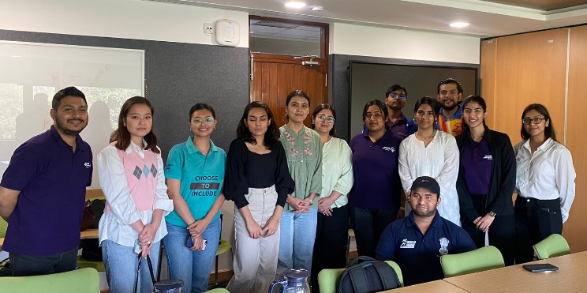
YuWaah is currently developing a youth-centric, one-stop digital ecosystem that will emerge as an aggregator marketplace, converging a multitude of platforms, tools, and resources for young people inside and outside of formal education systems to gain equitable, increased, and seamless access to skilling, economic and social impact opportunities. The invitation came as part of a plan that is likely to witness continuing interactions between the youth groups of the two organisations this year.

Tripura launches a Sports Centre
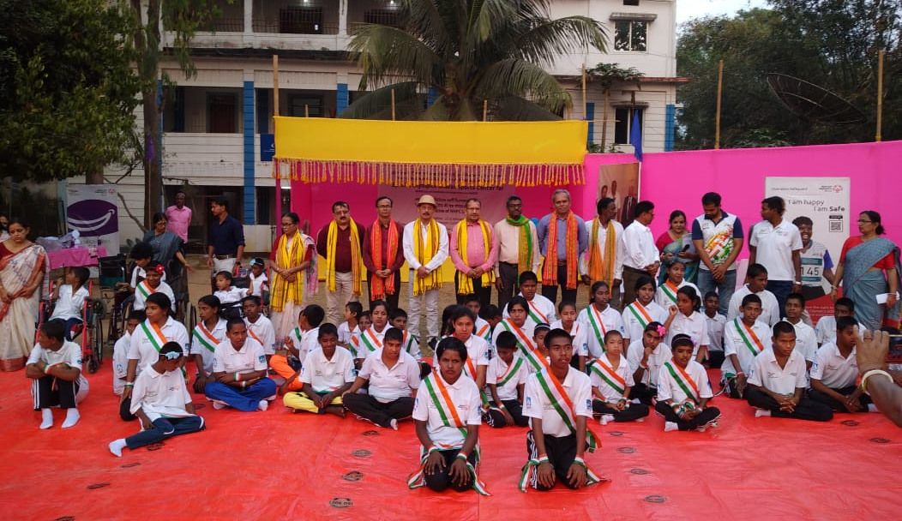
The state of Tripura opened a new chapter in its journey of Inclusion as it launched a Sports Centre, that comes through the support of NHPC, at the Abhoy Ashram Complex, Sepahijala. Mr. P. K. Chakraborty, Secy., Sports and Youth Affairs Dept., Govt. of Tripura presided over the function as Chief Guest, along with several other distinguished guests representing the Govt of Tripura and NHPC. The centre will be offering regular fitness and sports access to the Athletes across Athletics and Football, to begin with. It is likely to see an attendance of about 60 Athletes on five days of the week, providing a boost to development through sports to the local communities.
Strengthening the eco-system for Inclusive Youth leadership
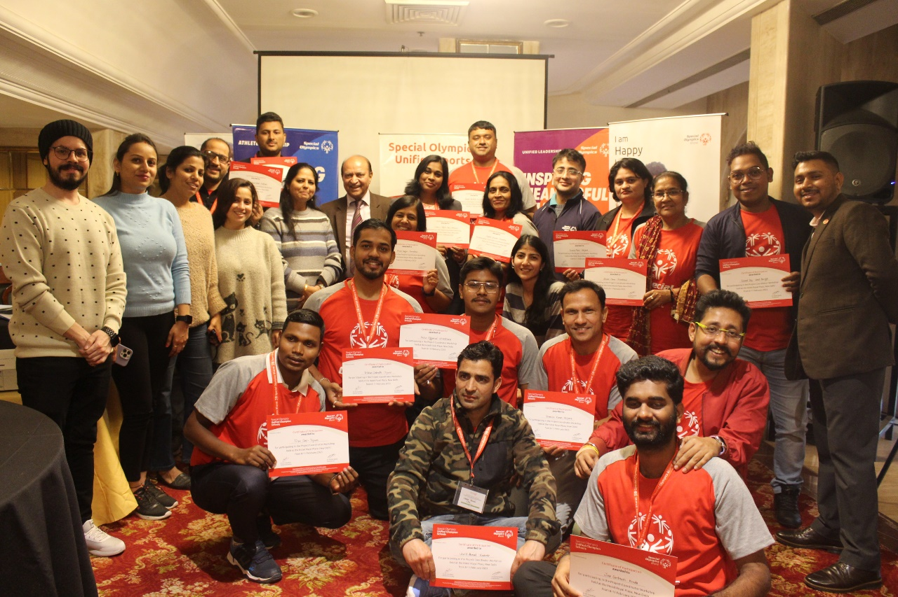
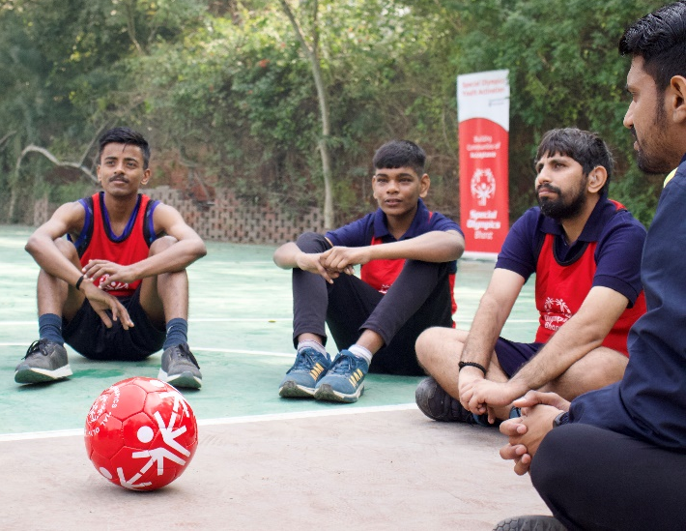
The Project Coordinator Workshop supported by Macquarie was held at the Hotel Royal Plaza, New Delhi from 8-11 February 2023 witnessing participation from eight states of India, to organise ‘Inclusive Youth leadership’ within their states. Two representatives from each of the identified states participated to understand the concept, program and its implementation while playing a critical role of mentoring the youth to work inclusively and lead. The three-day workshop was composed of two days of indoor sessions and the third that provided a Unified Sports experience. The program would position the states to reach out to schools, colleges, and universities to encourage Inclusion of Persons with Intellectual Disabilities through Sports and by offering opportunities for youth with and without intellectual disabilities to become agents of change within their school, community, and state. View Video
Inclusive youth leadership is when young people of all abilities are given opportunities to be leaders in their schools and communities. These leadership activities help students find their voices and teach them to become change agents in their communities by promoting equity and acceptance.

Special Athletes play Unified with the AIFF players

Athletes from Special Olympics Bharat (SO Bharat) combined with the players of All India Football Federation (AIFF) adding a new perspective to the second edition of the AIFF Hero Futsal Club Championship 2022-23 held at the KD Jadhav Indoor Hall, Indira Gandhi Stadium Complex, Delhi. Prior to the competition a coaches’ training oriented about 30 participants with Special Olympics Unified Sports and Inclusion of the Athletes with Intellectual Disability in the sports field and beyond. The Unified Futsal Championship (7-a-side) was played over an hour between teams that combined the players with and without Intellectual Disability. Mr Victor Hermans, FIFA Technical Consultant & legendary Futsal player, graced the event alongside several distinguished guests
In the words of Mr. Savio Medeira, Director, Coach Education: “we are also looking at Unified Football as a topic to be included in our official AIFF E Certificate Coaching Course in the immediate future. The E Certificate is our entry-level coaching course which focuses on Life Skills and Human Values along with introducing the basics of Football Coaching to first-timers and is undertaken by thousands of coaches every year on a pan-India level” More in the news
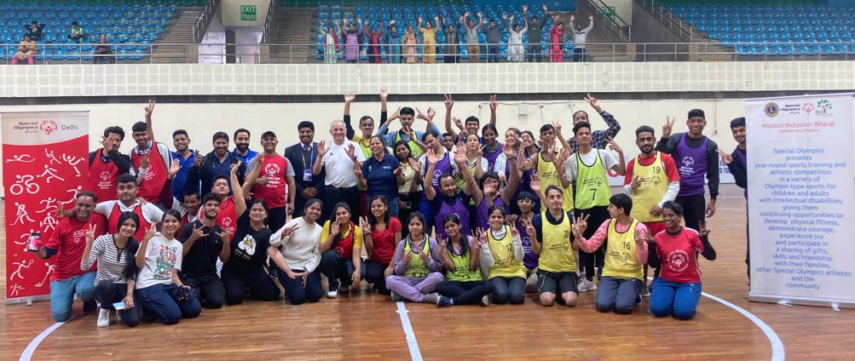

PARTNERS IN INCLUSION
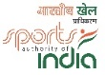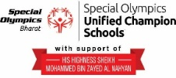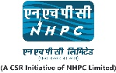
www.specialolympicsbharat.org | Facebook, Twitter, Instagram, You tube, Linkedin

