Greetings from Special Olympics Bharat
Sports Centres open in five states and counting
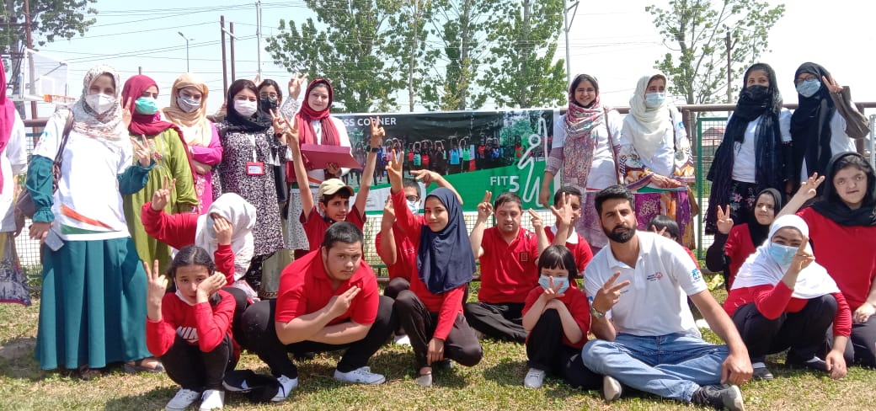
About 80 Athletes from Jammu and Srinagar would get a chance to play and develop through regular sports as SO Bharat steers into Jammu and Kashmir launching two sports centres there. The month of January saw the launch of the Sports Centres in Jammu & Kashmir, Union Territory of India, supported by NHPC. Athletics and football have begun, with a plan of offering other sports to the surrounding community, as well.

At the launch at the MAM Stadium, Mrs Nighat Gul, Secretary of the Sports Council, Jammu & Kashmir, welcomed the initiative as well as the 48 Athletes and other distinguished guests and officials present. She upheld the Sports Centres as being a giant step towards making sports important for the Athletes as well as the rest of the community and assured Dr. Ashwani Jojra, State Area Director of Special Olympics Bharat – Jammu & Kashmir, her consistent support in the days to come. Sahil Badyal, a Coach with the Special Olympics chapter for over 5 years, would lead the initiative, strengthening local sports access there.

A total of 19 centers have opened so far, across the states of Himachal Pradesh, Assam, J&K, Arunachal Pradesh and Tripura and the process is going on with an aim of building a lifestyle of sports

_______________

Towards a globally unified education system
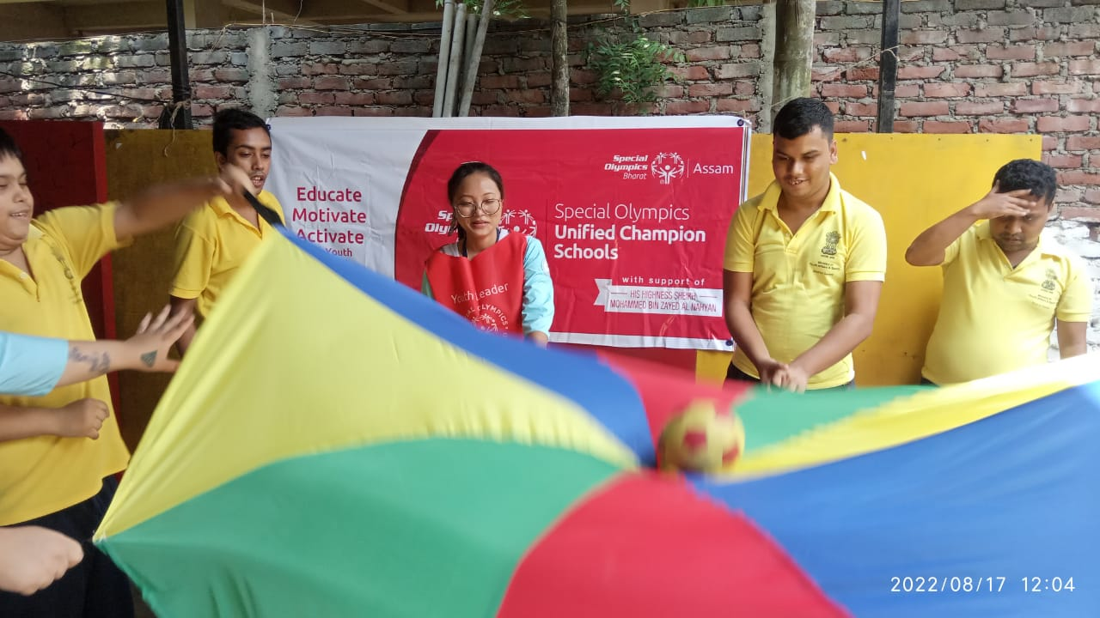
Special Olympics Program staff from the 17 Programs and 6 Regions visited Abu Dhabi to share experiences and best practises for sustaining and expanding Unified Champion Schools programming in their respective countries. Prior to the workshop, Researchers showcase their findings after having implemented socially inclusive activities worldwide. The presentations included Communicating with Government Stakeholders, Storytelling, Young Athletes etc, implying the participation & leadership of the youth, inclusively, across all the initiatives of Special Olympics at all levels

Through this support India formalised the initiative across 12 states, while implementing active participation of the youth in schools and colleges inclusively in sports and beyond in many others. The MBZ supported program , effectively since the latter half of the year 2020 has accomplished over 100 Unified Champion schools, training over 1100 youth with and without ID while engaging approx. 4000 athletes with and without ID in unified sports. The program is currently in progress across the 12 states of India. The program has witnessed three annual youth summits held in Delhi bringing together several youth pairs (youth with and without ID engaging in several programs and interactions together) and their adult mentors from 15-18 states

The support of the UAE covers 17 programs globally, including six old and 11 new, substantiating the importance of a globally unified education system and also their profound participation in establishing the system all over the world. Young people with intellectual disabilities are among those most marginalised by education systems globally. Even of those students that do achieve access, some estimate that less than 5% of children with disabilities complete school. To address these challenges, Special Olympics created Special Olympics Unified Champion Schools® program and His Highness Sheikh Mohammed Bin Zayed Al Nahyan, President of the U.A.E., Ruler of Abu Dhabi, and Supreme Commander of the U.A.E. Armed Forces announced their support to six countries in 2020, including India. The program emphasises on multiplying sports and expanded inclusive experiences between youth with and without Intellectual Disability in schools, colleges and universities.
_______________

Sportifying a life stream of hope
Jeevandhara Rehabilitation Research Institute, located in Bareilly Uttar Pradesh is an institute of Special Education, early intervention and rehabilitation studies. Its strength currently is approx. 200 students guided by a faculty of approx. 25 including admin, teachers, special educators, Coaches etc.
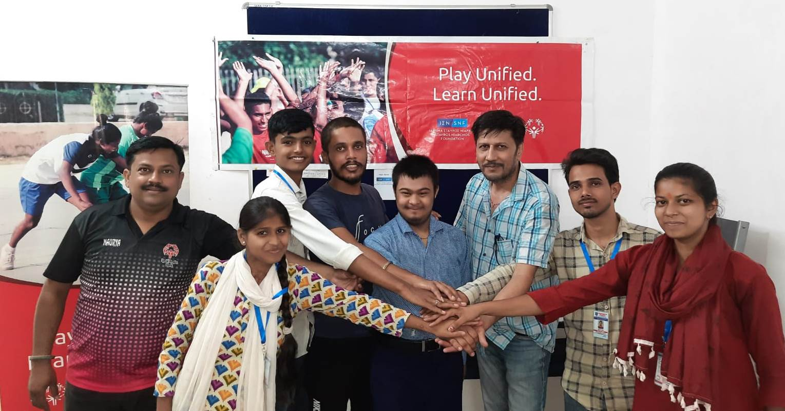
SNF (Stavros Niarchos Foundation) made Unified Sports a curriculum here by modifying the sports field and the environment consequently with regularised inclusive activities. Unified sports did take place earlier, but was rather erratic. Most of the time traditional sports were carried out and with limited resources in small grounds. The athletes competed within themselves, enjoying sports and each other’s company. However, the drive to push their limits and scale up performance was restricted. In 2018, the scene began to change. Unified Sports became regular. The institute saw increased engagements of Persons without Intellectual Disability with those with. Sports combined teams which focussed on achieving goals, on winning together! Differences in carrying out sporting tasks were prioritised over all other differences. The continuous exposure to unified/inclusive sports has changed the way that the stakeholders used to think and plan about sports Read More
_______________

The Odisha youth adventure into nature

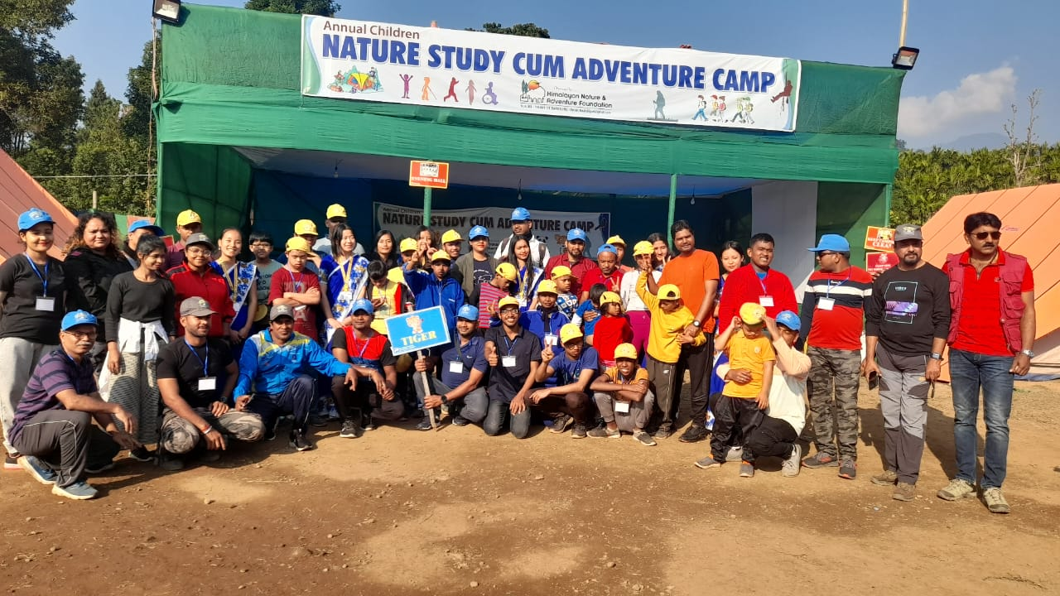
A Nature Study cum Adventure camp was a unique and creative idea of the state of Odisha to engage the youth inclusively. Having taken athletes earlier, this was the first time that an inclusive group of youth with and without Intellectual Disability went together. The camp was held in Kalimpong,West Bengal in collaboration with the Open Learning System (OLS). The youth from Odisha were accompanied by the officials. The five-day experience included an assortment of activities that brought the youth closer to nature. They collectively observed the flora fauna of the area, discussing the same with each other. Wall climbing, commando walk, jungle trek etc. were the other events they participated in, which wove together fitness, fun and learning.
_______________

The wheels keep rolling as the cyclists aim to win at the Berlin Games 2023
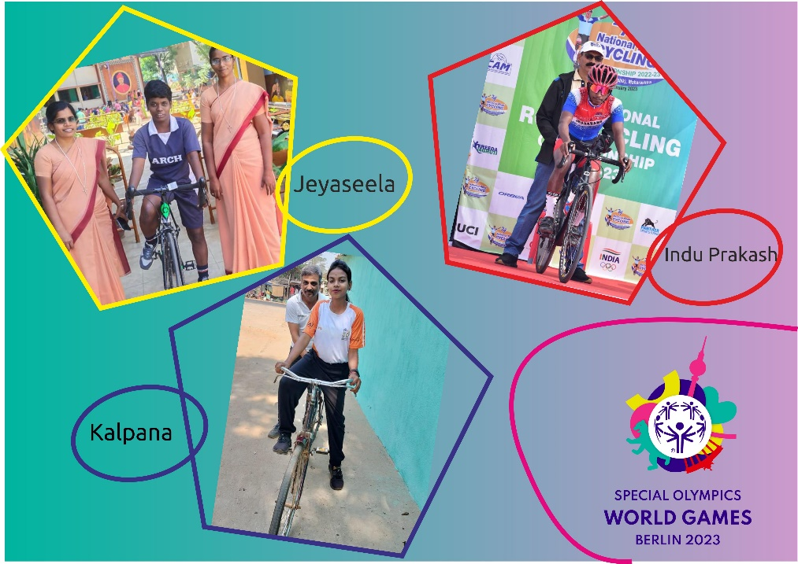
What brings Kalpana from Odisha, Jeyaseela from Tamil Nadu and Indu Prakash from Jharkhand is their passion for cycling. They share a common experience of cycling to run errands, which placed them in a position to block a spot for themselves at the global mega event- the Special Olympics World Summer Games to be held in Berlin, Germany in June 2023. At the National Camp held a few months back all three also got a chance to use new bikes, which added joy and deepen an inspiration to continue to discover and develop their abilities to compete at a global level.
Preparing for the event has already hinted at elements of transformation within and around them, with each having their own challenges to fight. Jeyaseela, rejected by her siblings after losing both her parents, have them reaching back to her and cheering her for the competition. Kalpana is a role model for a budding athlete who is already pitching for the next World games, following her example. Kalpana has shown tremendous improvement in her confidence levels demonstrating a potential for leadership. Indu Prakash has seen his parents struggle in their daily lives and is determined to make them proud of himself and to support him some day. He sees the World games as an entry into a world of positivity and change. While they practise, their mentors ensure that they stand behind for the required motivation and guidance. All of them are currently cycling approx. 40kms daily to prove their sweat to themselves, to their families and communities. More about them
_______________

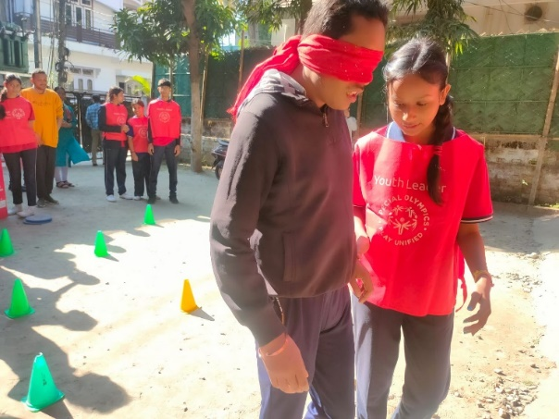
Disability, the inability to see the ability
Constantly exploring creative ways of sensitizing the youth, the youth leaders from Assam used ‘Minesweep’ to experience Inclusion. The Unified pairs from each of the teams had to guide the other pair to walk avoiding the mines. While one of the pair was blind-folded, the other guided him/her from point ‘A’ to point ’B’. Packed with fun, the game encouraged team coordination, communication between the pair, trust building etc. The game was followed by an open interaction within the group where each asked the other their guiding principles. Parts of the Young Athlete kit was used to make the game colourful and enjoyable.
The activity was part of one of the Unified Champion School events held in Assam engaging the students of Ashadeep Special School with Axel Public School.. One of the Youth leaders from the Axel Public School quoted- "Disability is the inability to see ability"
We joined ,we played, we enjoyed and learned that they are not different from us they are part of us and they deserve the same respect as we do. If they can represent our country in international level then why can't we give respect and treat them like one of us”
_______________

Shrey Kadian, softballer, adds another feather in his cap
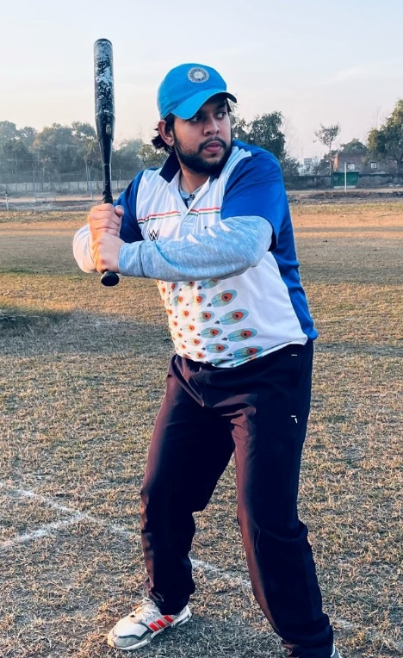
Shrey easily recalls the rules, the agenda and the experience of qualifying a coaching course which he completed recently. About the Umpire, score sheet, skills, number of players, comes back to him as he relates his experience to everyone. Shrey, currently a representative of the Special Olympics Asia Pacific region at the Special Olympics Global Athlete leadership council refuses to let go his dream of popularising Softball in India. In 2015 he was the Vice-Captain of the Indian team that bagged a Gold in its inaugural participation in the sport at the Special Olympics World Summer Games held in LA, USA. His journey has reached a point where he is now a player with the Uttar Pradesh State- Softball Association, being the only Special Olympics athlete amongst the rest of the players.
Life’s challenges never cease, but he continues to accept and overcome them impressing everyone that abilities are special to each; his latest being at a camp where it took 2-3 days to have the rest get familiar with his differences. A nearly 20-day camp was held in Patiala, Punjab where he was part of 19 softballers who were completing a module to qualify a certification course in Softball. Shrey has been awarded a certificate for successfully completing a six-week certification course in sports coaching, specialising in softball, under the aegis of the Sports Authority of India (SAI) & Netaji Subhash National Institute of Sports Patiala. Currently, working as a Sports Coach at the Cornerstone India Foundation, the certificate positions him favourably in applying for jobs at schools, universities, clubs and academies. As a Coach he shares his learning that teaches him to be patient and respectful Dissatisfied with an urge to gain more, Shrey, a while feels proud of his achievement, he plans to not only be a player but train all others, with or without Intellectual Disabilities.
_______________

Purple Fest in Goa celebrates Diversity
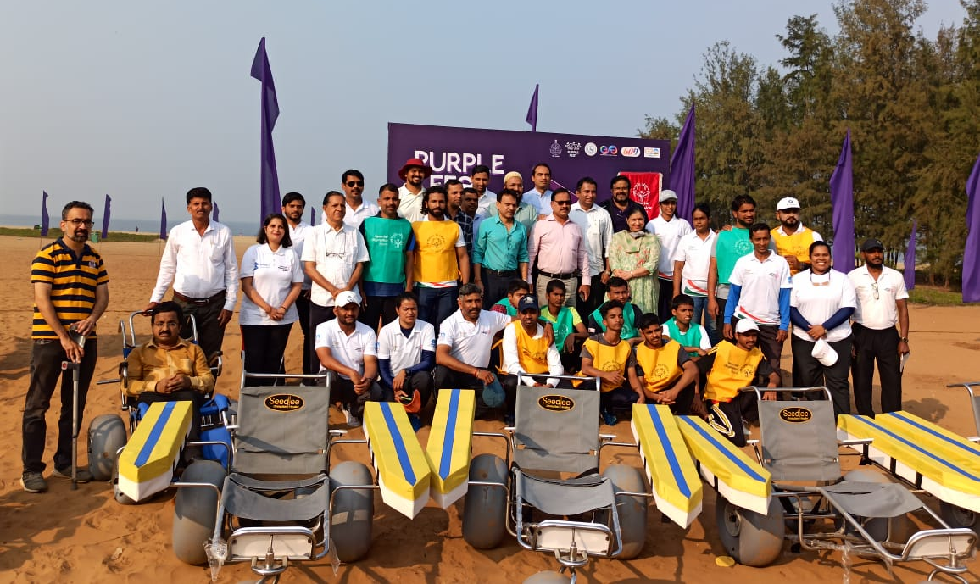
Organised by the State Commissioner for Persons with Disabilities, in collaboration with the Directorate of Social Welfare and Entertainment Society of Goa, the Purple Fest 2023 witnessed participation of over 300 mainstream and 25 special schools of Goa. Celebrating diversity, the event unfolded a bonanza of cultural programs, exhibitions activities, sports, panel discussions etc. Special Olympics Athletes stamped their presence for the first time at the festival. A day prior to the launch, approx 25 athletes partnered with volunteers, introducing the concept of Unified Beach Cricket to the city that attended the event in huge numbers across the three-day duration.
‘Baggo’ too was introduced by Special Olympics that combined over 600 persons with and without Intellectual disability, and was conducted throughout the duration of the event. Mr Victor Vaz, National Sports Director, joined the other esteemed panellists, contributing to a discussion around making stadiums more accessible to Persons with Disabilities. While a few schools are already part of the ongoing Unified Champion School program in Goa, many more expressed interest in ‘Unified Sports’. The purple Fest saw much enthusiasm and hopes to spread across other states of India as well. Read more
_______________

PARTNERS IN INCLUSION
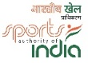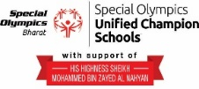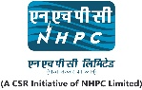
www.specialolympicsbharat.org | Facebook, Twitter, Instagram, You tube, Linkedin

