Greetings from Special Olympics Bharat
Special Athletes enjoy an awareness and fitness walk with TATA Cummins
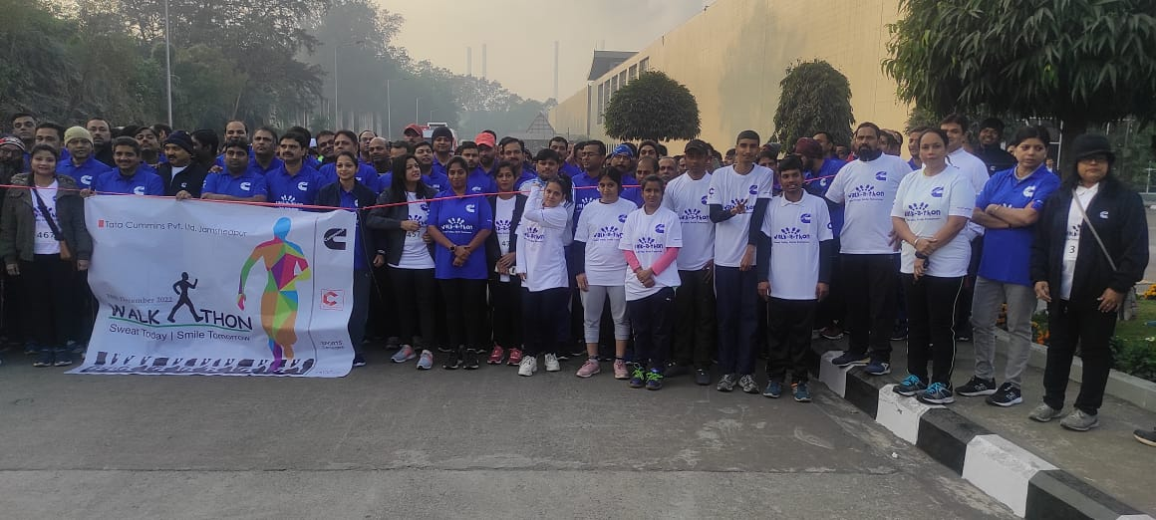
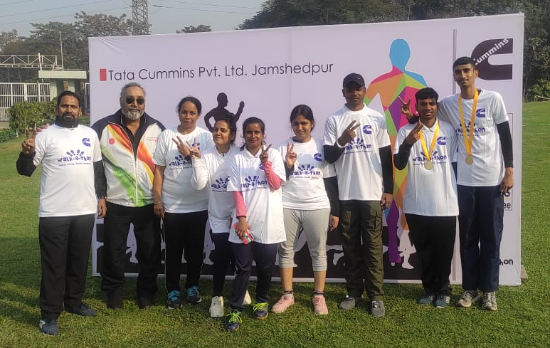
The Athletes of Jamshedpur Jharkhand, joined approx. 750 employees of TATA Cummins at the first ever Walk-a-thon organized by the company, with an aim to spread the importance of health and fitness. They, together, covered a distance of 5 kms adding an element of fun throughout the way. The run was flagged off by Mr Ramphal Nehra, Head Plant & Mr Manish Jain, GM-HR TATA Cummins and Mr Satbir Singh Sahota veteran sportsperson, cyclist and Asst. Area Director, SO Bharat Jharkhand. The platform also spotlighted the Athletes from the city who are preparing to participate in the Special Olympics World Summer Games Berlin 2023.
“The inaugural and inclusive initiative of TATA Cummins is likely to be an annual feature with more and more Athletes joining in. Our objective is to create and multiply opportunities of engagements between persons with and without Intellectual Disability. With awareness will come acceptance that we all value and are striving for”- Mr Satbir Singh Sahota
_____________________
Child Health Intervention and Maternal Evaluation (CHIME) by the Amity University UP
6000 Special Olympics athletes all over India, between ages 2 and 8, are currently engaged in developmental skills that would equip them to be better positioned to enter the sports arena. The locomotor and social skills they are introduced to, are part of the Special Olympics Young Athletes program that provides children of all abilities the same opportunities to advance in core developmental milestones. Typically, as conducted in the Sunrise Learning School Noida end of 2022, a two-week program of Young Athletes was conducted combining the school faculty, Athletes, their families and Coaches in a fun way approach for their children to stay active and establish healthy habits.
Supported by the Gates Foundation, the program expands to include regular health monitoring of the Young Athletes and a constant dialogue with their families. To assess the impact of the program Child Health Intervention and Maternal Evaluation (CHIME) is being conducted on 600 young athletes by the Amity University UP, NOIDA all over India. Parallelly a new initiative was introduced aiming to carry out pediatric screening on 60 Young Athletes. The evaluation promises to get us closer to the changes coming about through the Young Athletes Program this year.
_____________________
The Asha Kiran Athletes model hope and change for everyone
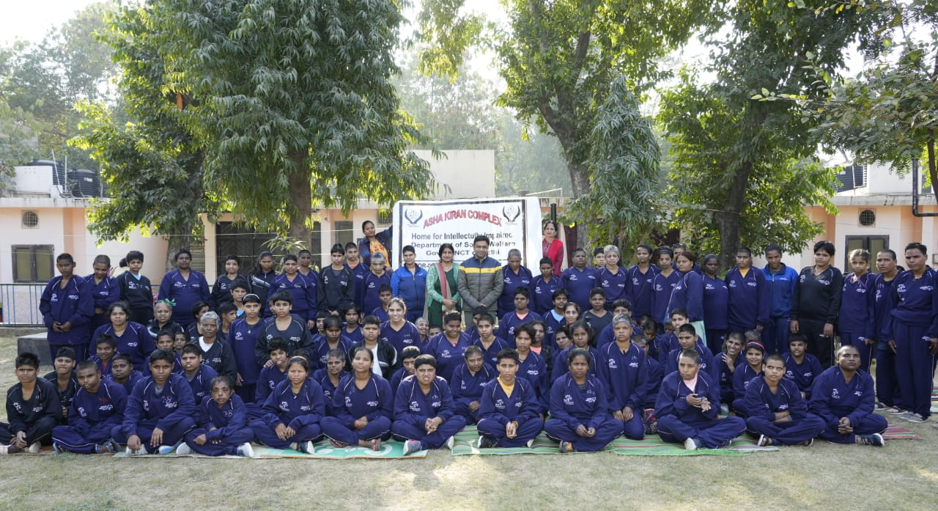
Asha Kiran , a home for abandoned, supported by the Delhi Social Welfare Department, has been associated with SO Bharat since 2004. The approx. 900 residents with Intellectual Disabilities have been engaged with SO Bharat in Sports and Health, including about 40 of them having been trained as Health Messengers.
The year 2015 was a turning point in the institute, as for the first time 9 residents were selected to represent SO Bharat at a global mega-event, the SO World Summer Games 2015 held in LA USA. These residents got passports, something that was done in the institute for the first time. They represented SO Bharat in Powerlifting, Athletics, Volleyball, Softball and Handball and won 9 medals. Since then, seventeen athletes from Asha Kiran have participated in the Special Olympics World Games held in 2015, 2017 and 2019. Four are preparing to participate in the Berlin Games 2023 in Basketball, Football, Powerlifting & Volleyball. As the number of residents participating in one sport or the other becomes a constant, the diversity of sports offered to them is expanding too. Read More
_____________________
Delhi Mega Sports
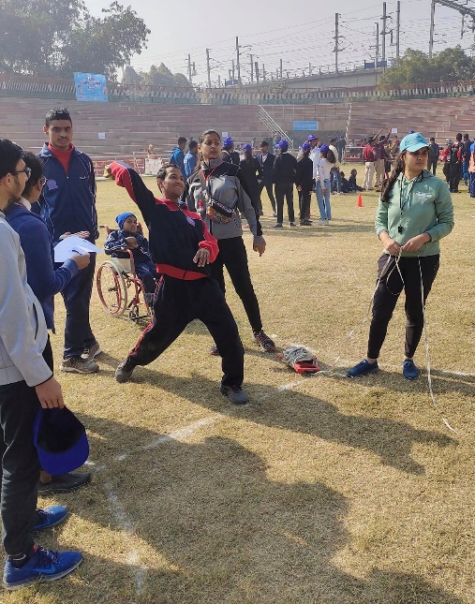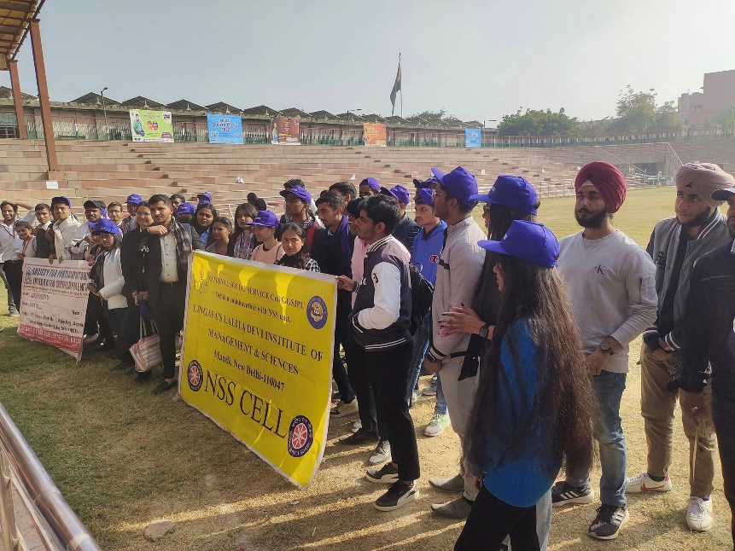
The Brahmshakti Special School conducted a mega sports event that witnessed 350 Athletes from 18 schools of Delhi. The event held at the Dr. Sahib Singh Verma Stadium, Sector – 16, Dwarka, engaged over 60 volunteers from Netaji Subhas University of Technology (NSUT) , Bharati College, GTBP(Guru Tegh Bahadur Institute of Technology) School and Lingayas University. Bocce,50 mtr Run ,25 mtr Run ,10 mtr Assistant Walk, Shot put, standing long Jump saw an enthusiastic participation of the athletes at the very first event held at the stadium. This Annual sports day of the school scaled several notches to spread the message of abilities and inclusion. The constant endeavour of SO Bharat Delhi to expand reach of schools had Brahmshakti re-connect after a few years.
_____________________
ISAME cheers inclusion as the LEOs join the Special Olympics Bharat Athletes in sports
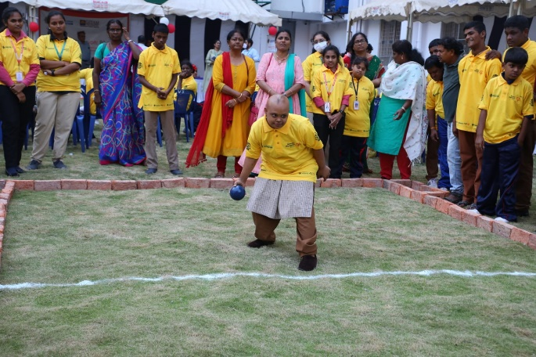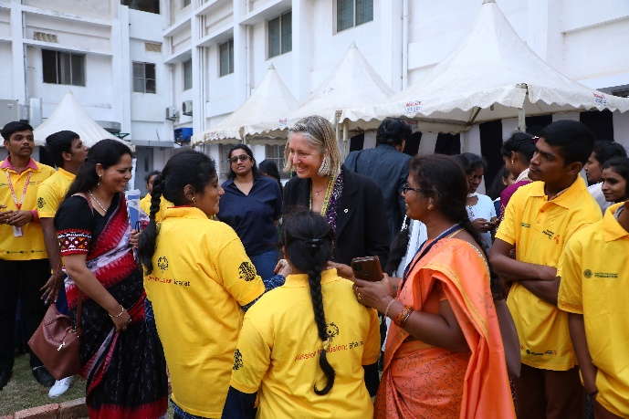
A Unified Bocce event combined over 100 Special Olympics Athletes, LEOs Special Olympics officials and members of the Lions Clubs International Foundation at the Gitam University, Vishakapatnam, Andhra Pradesh, on the occasion of ISAME. The event witnessed the gracious presence of Douglas X. Alexander Immediate Past International President &LCIF Chairperson; Lion Annemarie Hill, Vice President, Global Health Operations, Special Olympics International; Dr DG Chaudhari, General Secretary, SO Bharat joined by several esteemed members and officials of both the organizations. The Lions and LEOs joined the SO Athletes in Unified Bocce.
Having travelled to India to drive through the message of the importance of Sports as a catalyst to Inclusion Lion Hill said, “Through the common medium of sports, Special Olympics provides youth without intellectual disabilities a fun way to engage, learn from, support and most importantly, play, with youth with intellectual disabilities. Few leverage this opportunity better than Leo’s who consistently engage in Unified Sports as part of the Mission: Inclusion platform that Lions Clubs International and Special Olympics share. By playing together on the sports field, Leo’s learn acceptance, courage and resilience which positions them well to build the inclusive future we all strive for”
An MoU was signed between the two entities, jointly agreeing to advance their shared goal of inclusion of children with intellectual disabilities through increased inclusive engagements, service and support across India. ISAME is the constitutional area of Lions Clubs International that stands for India, South Asia and the Middle East that meets every year. LEO ISAAME Forum 2022 is the international youth conference, that is part of the program, with this year’s theme of ‘Together Towards Tomorrow’
_____________________
Special Care for a Special Smile
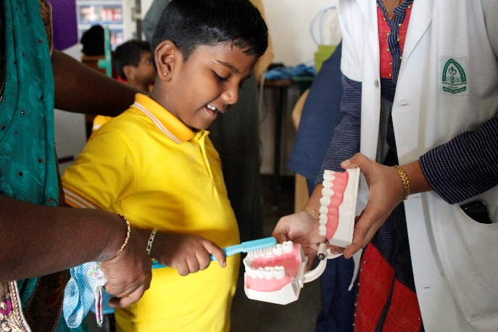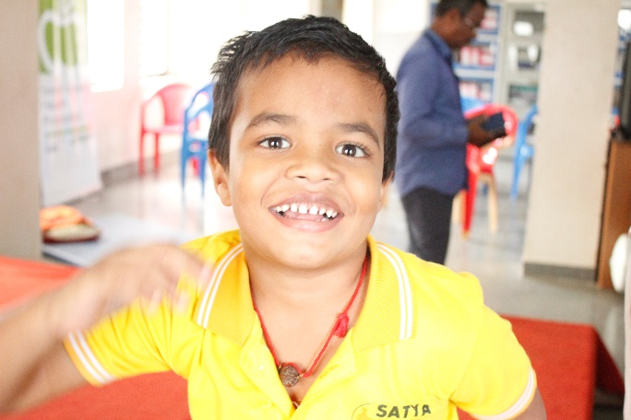
Ravi Mathi, a javelin athlete from Puducherry could not communicate when his teeth hurt. The reason was quite straightforward. He was not brushing his teeth properly or regularly. His parents keeping busy could not monitor so closely as well. He would be cranky and restless when in pain. At the Special Olympics Special Smiles (Dental) camp held in Puducherry, his condition surfaced and taken care of. This is not an isolated case but, exists largely across persons with Intellectual Disability. As regular oral care is not considered important, in the wake of the larger aspects to be taken care of by the families, regular dental check-ups are not be considered.
Special Olympics provides a platform to uphold the health of the Athletes, as is important for any athlete without an Intellectual Disability, directly impacting their performance in sports. It covers oral care (amongst other health parameters) comprehensively as was done in the dental camp held in Puducherry. Children were checked for cavities; gum disease and infections; ultrasonic scaling treatment was done to remove plaque build-up. “At the camp we also provided comprehensive oral health care information, including offering free dental screenings and instructions on correct brushing and flossing techniques to children with special needs, essentially to the parents and guardians of persons with Intellectual and developmental disability”- said Dr Dr Senthil.M, Team Public Health Dentistry, Indira Gandhi Institute of Dental sciences, Sri Balaji Vidyapeeth University.
A dental screening camp was organized by Special Olympics Bharat Pondicherry and the Department of Pediatric Preventive Dentistry Indira Gandhi College last month.83 children were screened, ultrasonic scaling was done for 64 children, 3 tooth extractions were done, 9 restoration while 7 children had good oral hygiene
_____________________
Expanding Community Outreach by exploring unprecedented avenues
Shri Gauhati Gaushala (a shelter for cows), located in the Kamrup district in Assam recently, open doors for a Special Olympics Bharat Sport Center. The sports space is surrounded by a pleasing green cover. There is also an unusual presence of an enclosure that houses 600 -700 cows. A passion for promoting Inclusion could be discovered anywhere such as in this case where Mr Jaiprakash Goenka, the President of the Gaushala, attended a sports camp playing Unified Bocce himself, some 7-8 months back. Gaining inspiration from the Athletes he offered space, within his premises, to run a Sports Centre.
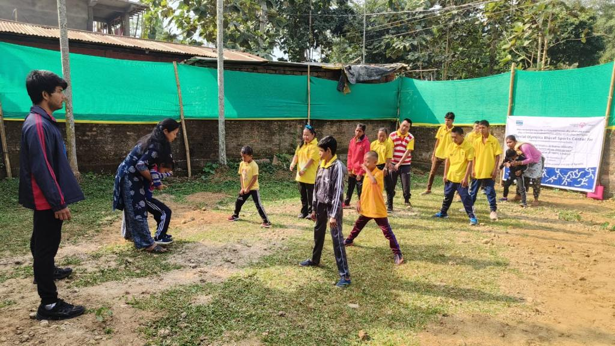
Since November 2022 the landscape has come alive with the sound and energy of sports, engaging over 50-60 Athletes daily, for about 2 hours. The change is felt across different stakeholders. According to coach Fardeen Khan, “regular sporting activity is reducing aggression in a few Athletes. He is pleased to observe that the Coach assistants too, who showed a low level of confidence initially have started to take charge of sessions independently.” Coach Assistants are athletes who have assumed the role of a coach. The daily roll-out includes stretching, football and cooling exercises at the centre here. Akankshya Bhuvan, the project -in-charge of the North East region shares that the mobility and fitness that sports can get is unmatched when compared to all other activities athletes with IDD are engaged in. She fondly recalls an athlete, deft at Yoga, came up to her saying, “I am a Yoga Champion. We’ll do Yoga as well”. Dr Anjana Goswami, Area Director SO Bharat Assam is happy to see over here, an opportunity for the families to be physically present to witness how the special athletes are trained in sports. Their growing interest and trust could be substantiated through the Christmas celebrations last month that had all the parents pool in funds to celebrate the festival at the Centre.
_____________________
An athlete who is stamping his presence as a leader
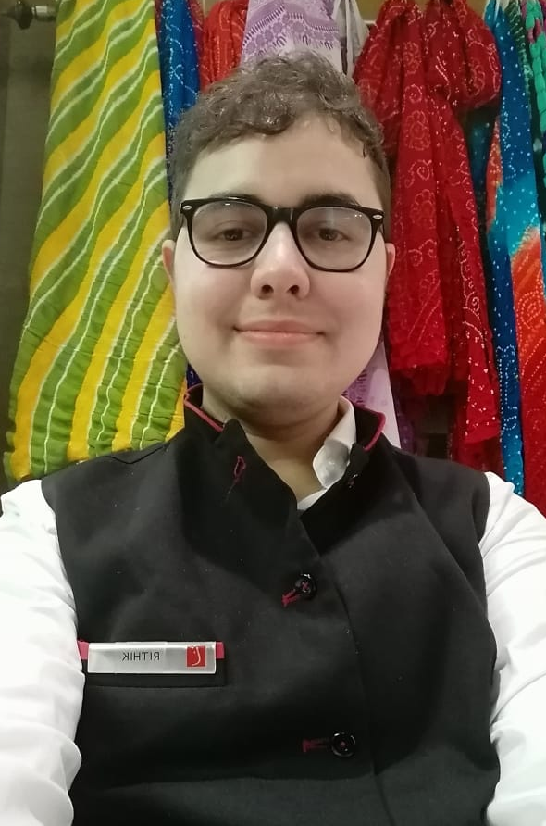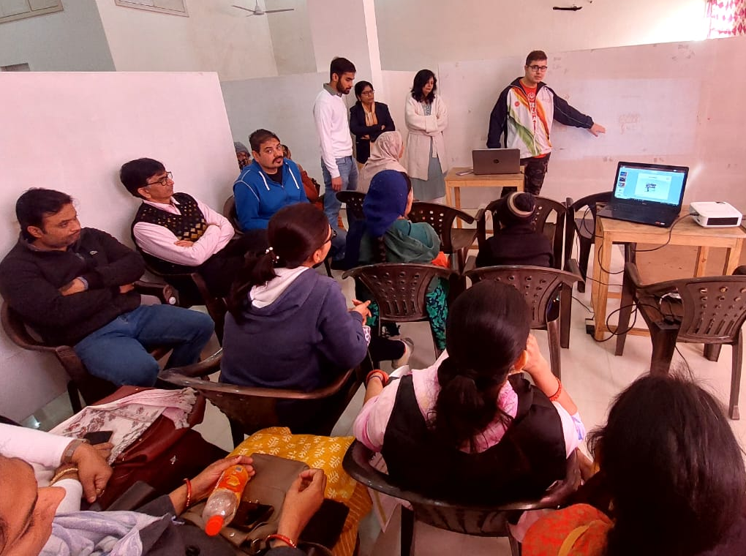
Rithik Hukku, a medallist and an Athlete leader from the state of Rajasthan recently got a job with The Lalit , Jaipur as a Guest Service associate. His job entails briefing the hotel guests about the available facilities and the shop that he looks after. Rithik is enjoying his job at the hotel that demonstrates hospitality and inclusion with the same fervour. Fulfilling his duties over here does not diminish his role as an ambassador of SO Bharat.
At the Rajasthan State Games held recently, he introduced SO Bharat and Athlete leadership to Coaches from the participating 22 districts while also to about 28 School representatives from the same districts. He enlightened them about the SOI e learning course and also about his constant endeavour to discover more athlete leaders and mentors from the state. A school from Bikaner even invited him to the district to extend the training there. Rithik also conducted a similar session with over 20 parents of the students of a new school, Aditi Vidhya Foundation and St Wilfred’s School Jaipur. Always enthusiastic to do more for spreading awareness about SO Bharat, Rithik is currently planning a State Youth Leadership Summit at the Apex University for the month of February 2023
Special Olympics believes that if we want an accepting world, the athletes must be allowed to contribute in ways beyond the sports field. One of the most powerful ways is to create opportunities for people with intellectual disabilities to develop and demonstrate their abilities in leadership roles. By carrying on relentlessly to reach out to new persons and organisations, Rithik is proving himself as a model Athlete leader
_____________________

The Athletes of Goa escort the players of FC Goa
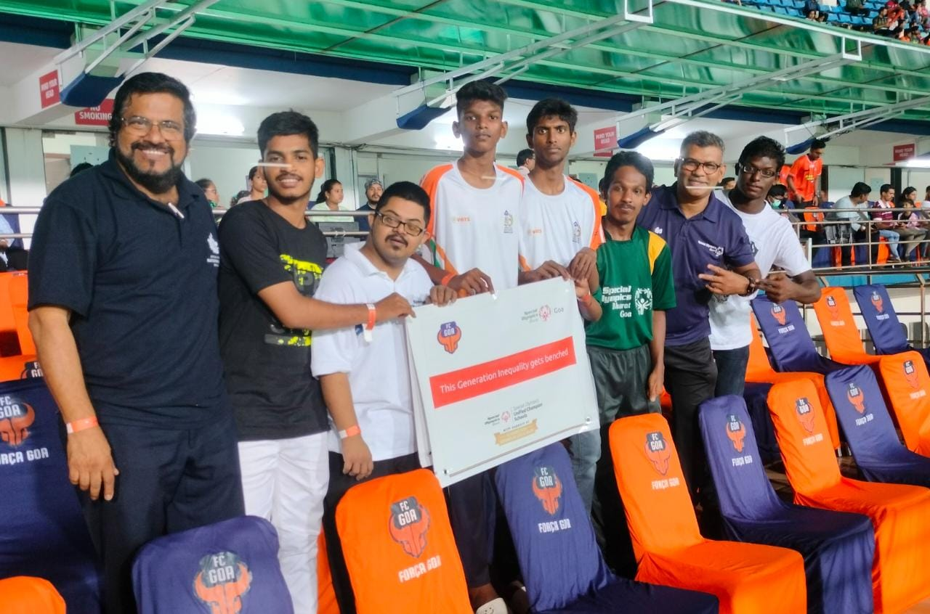
The Forca Goa Foundation has been associated with Special Olympics Bharat- Goa since 2018. After a long break and several meetings and conversations, the connection between the club and SO Bharat re-ignited. The Athletes were invited for a match held in December 2022 at Fatorda Stadium, swiftly followed by an invitation to the athletes for escorting the players of FC Goa in their match against the Kerela blasters, a few days back. A plan to jointly scale-up the inclusion of Persons with Intellectual Disability is building, once again.
“We (Forca Goa Foundation) aim to make football is inclusive and accessible and through our partnership with SO Bharat, we have trained our coaches to work with differently abled individuals. We are proud to have the FC Goa first team walk alongside the specially-abled athletes today. Our players are an inspiration to many and if they support such a noble cause, their fans in turn will support and advocate for the same. The goal is to raise awareness and sensitize the general public on the challenges that individuals with special needs face”, Ishita Godinho, Head - Forca Goa Foundation

PARTNERS IN INCLUSION
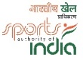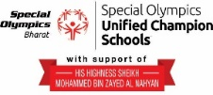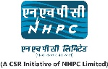
www.specialolympicsbharat.org | Facebook, Twitter, Instagram, You tube, Linkedin

